1. 编译支持视频输出的 QEMU

支持视频输出的 QEMU

git clone -b display <https://gitlab.com/wangjunqiang/qemu.git>

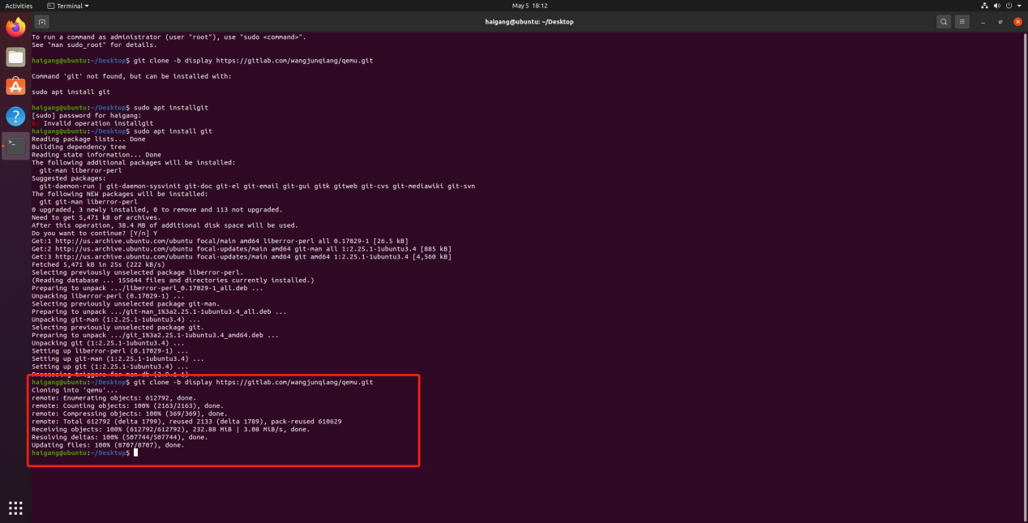  
2.安装 qemu-riscv64

2.1安装必要的构建工具

sudo apt install build-essential autoconf automake autotools-dev pkg-config bc curl gawk git bison flex texinfo gperf libtool patchutils mingw-w64 libmpc-dev libmpfr-dev libgmp-dev libexpat-dev libfdt-dev zlib1g-dev libglib2.0-dev libpixman-1-dev libncurses5-dev libncursesw5-dev meson libvirglrenderer-dev libsdl2-dev -y

sudo add-apt-repository ppa:deadsnakes/ppa

sudo apt install python3.9 python3-pip -y

sudo apt install -f

pip3 install meson

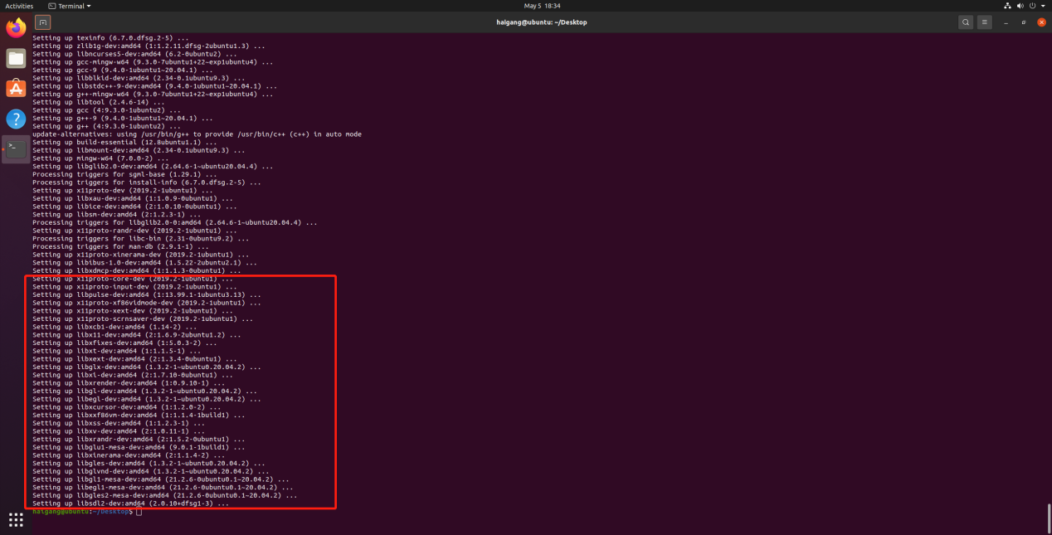

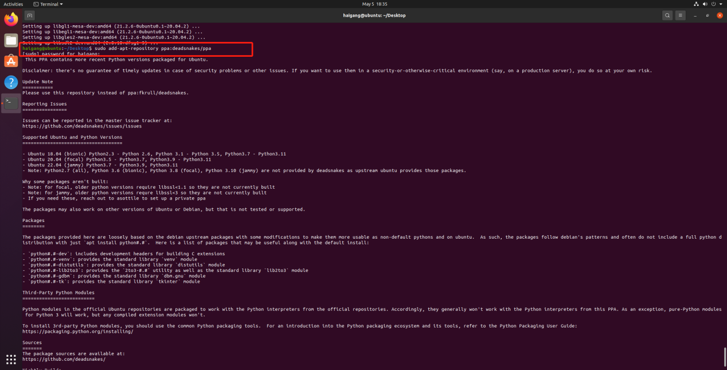

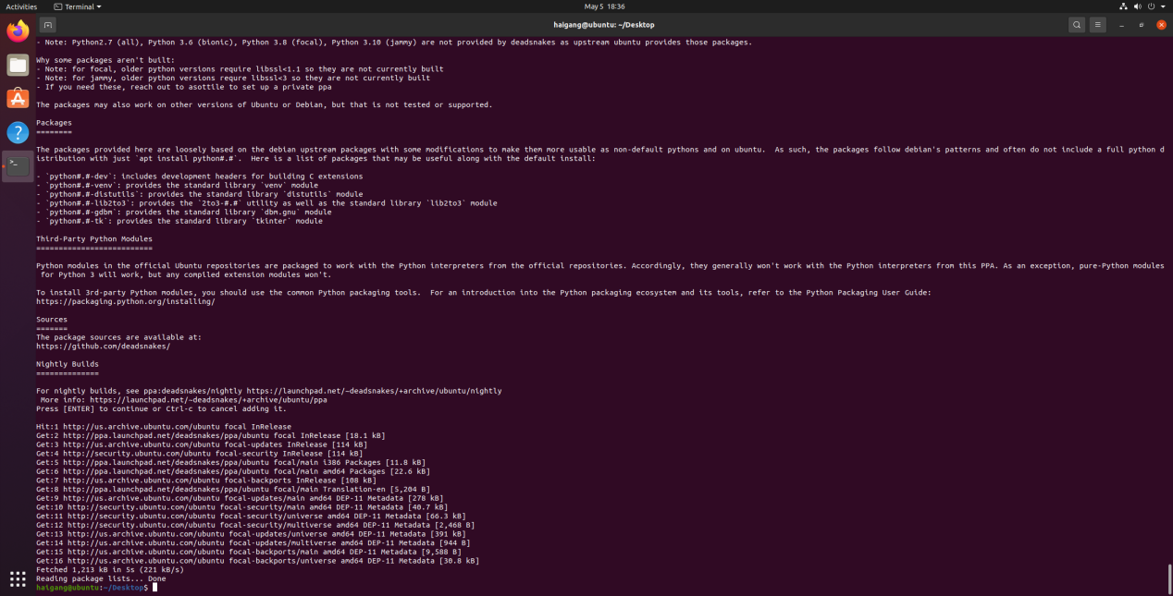

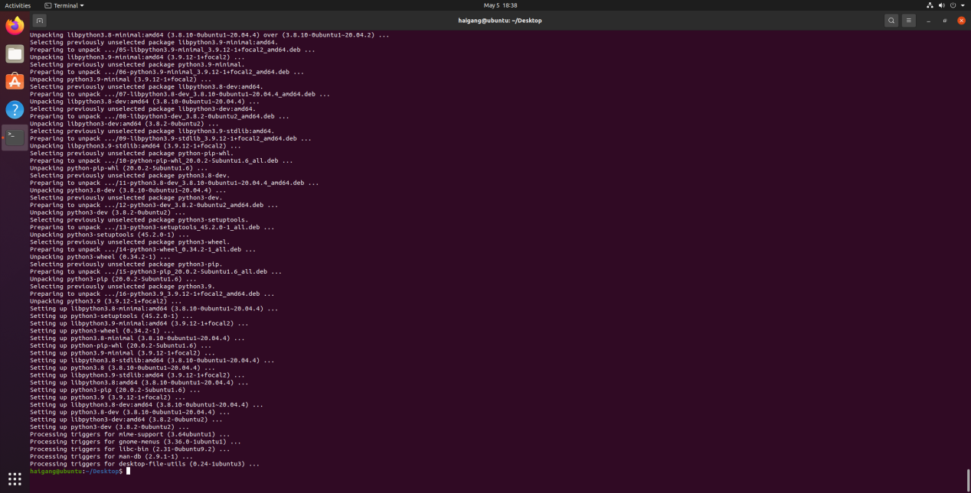

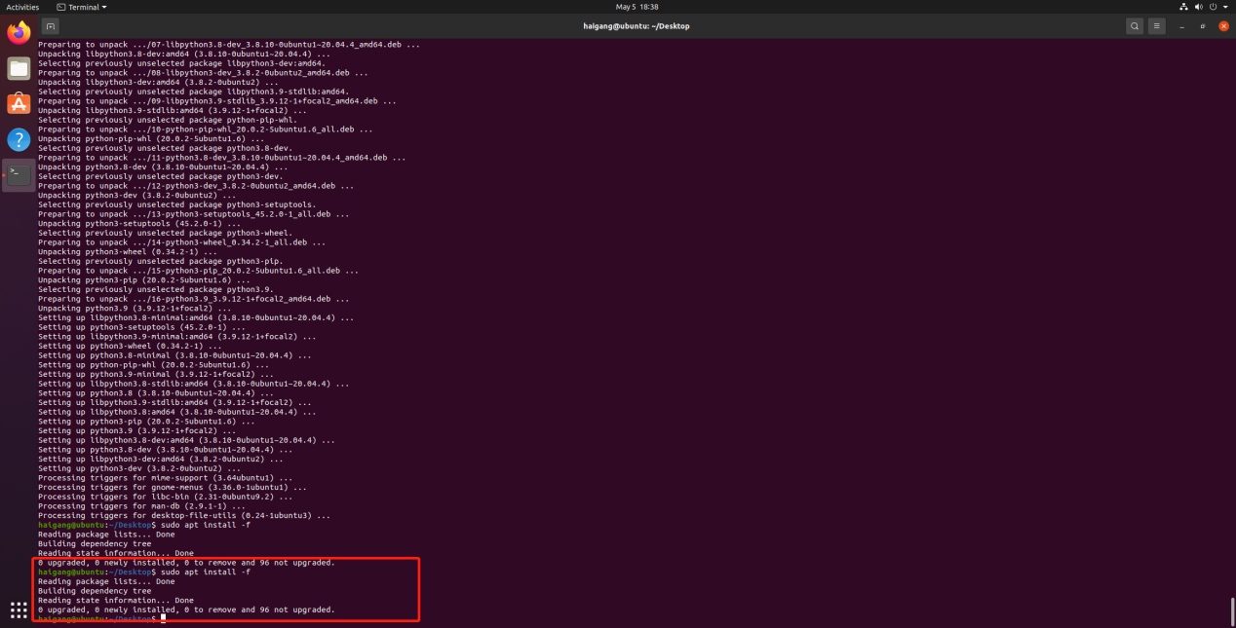

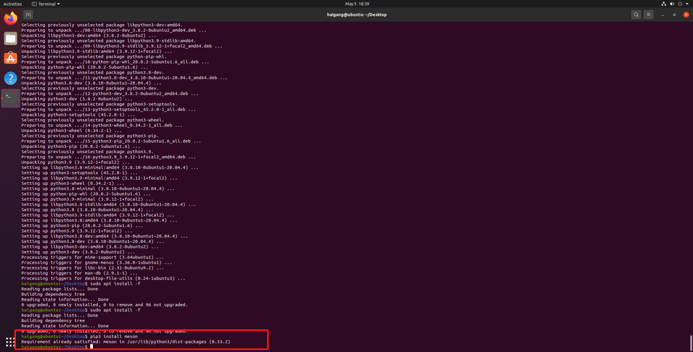

下载支持视频输出QEMU 源码包

git clone -b display <https://gitlab.com/wangjunqiang/qemu.git>

cd qemu

git submodule init

git submodule update --recursive

mkdir build

cd build

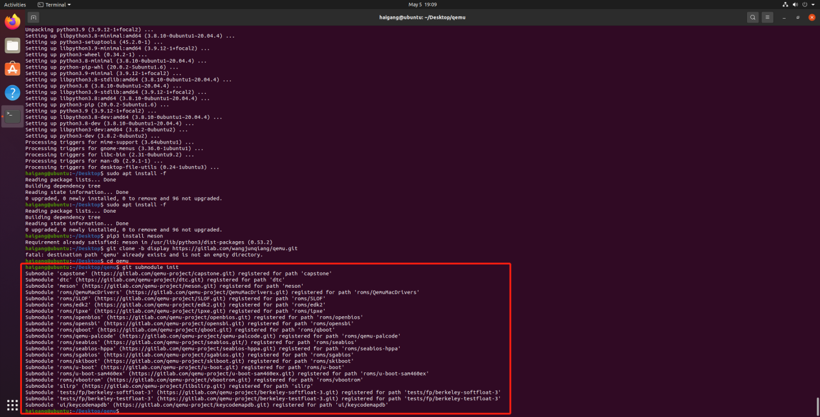

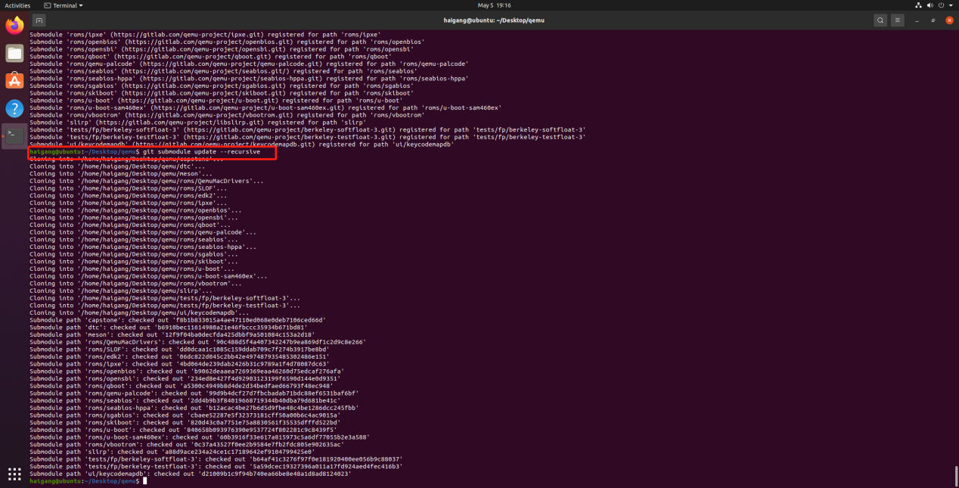

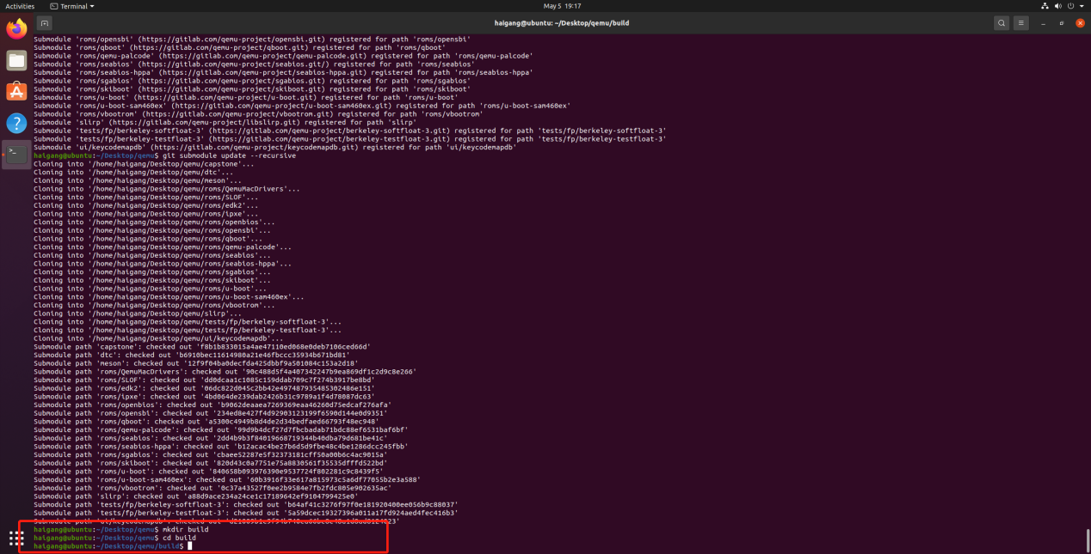

配置riscv64-qemu

../configure --enable-kvm --enable-sdl --enable-gtk --enable-virglrenderer --enable-opengl --target-list=riscv64-softmmu,riscv64-linux-user --prefix=/home/haigang/Desktop/qemu

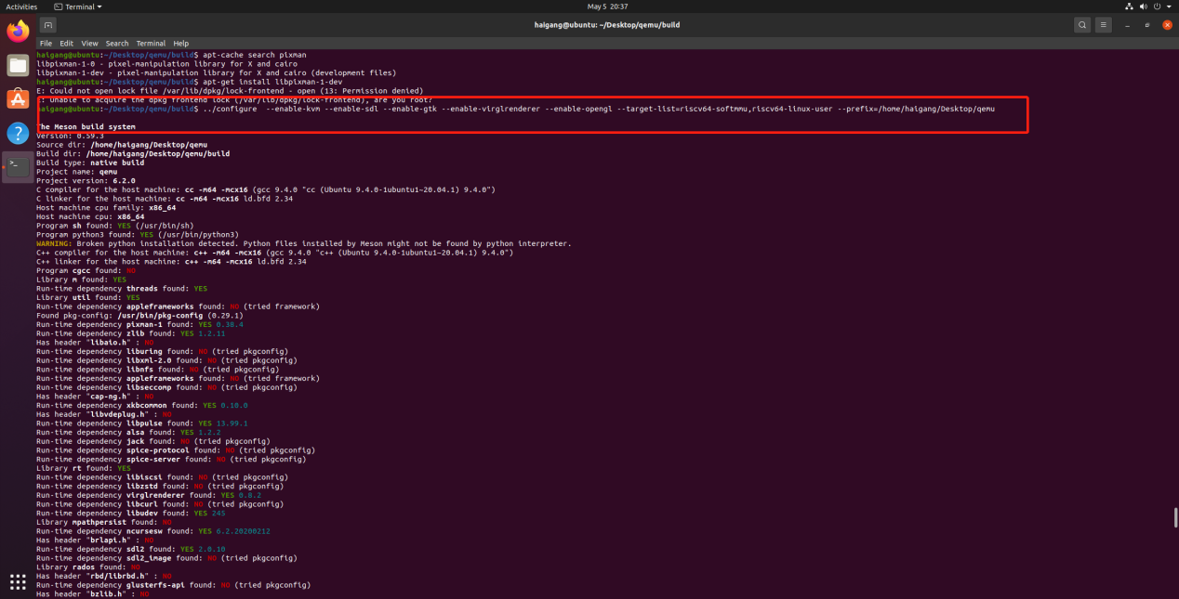

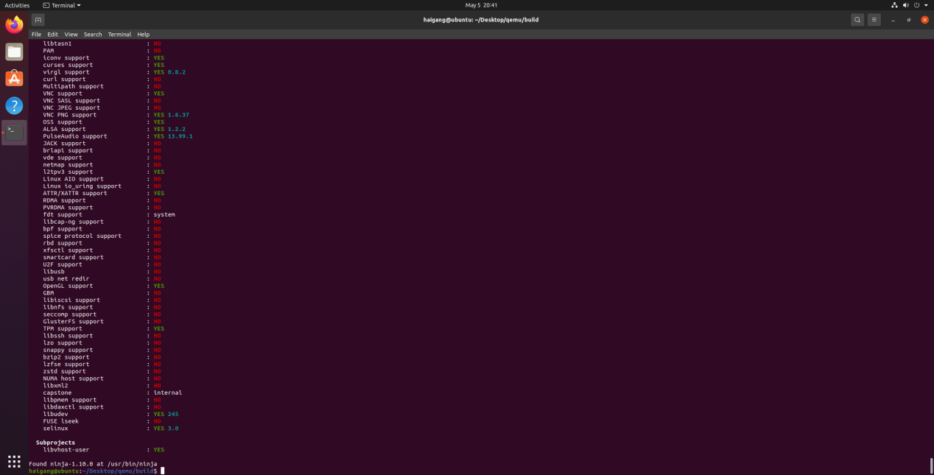

编译

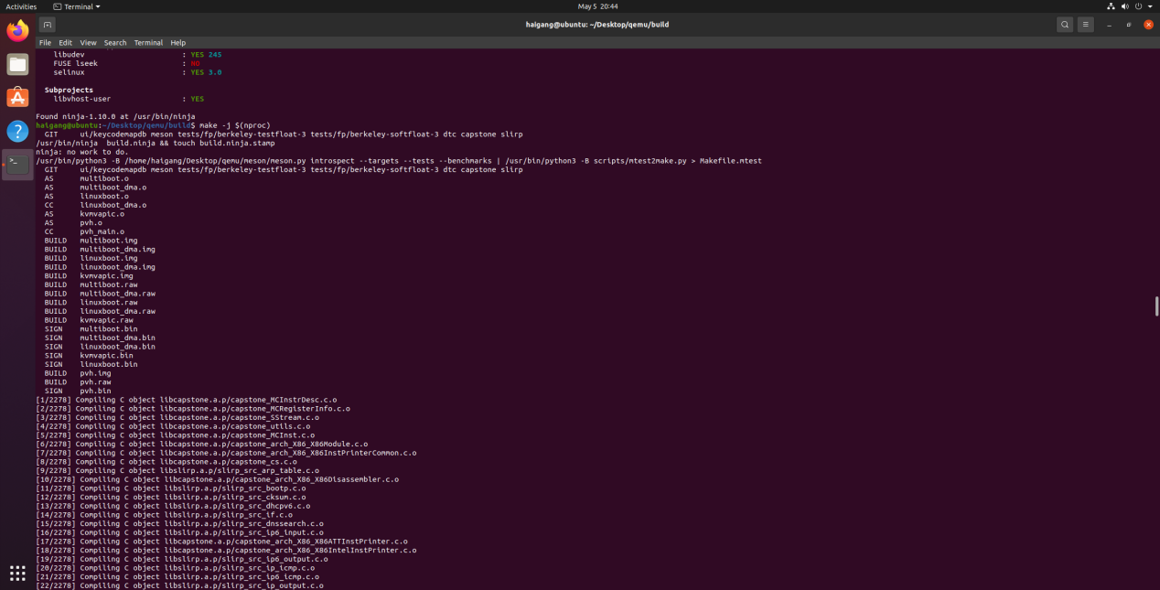

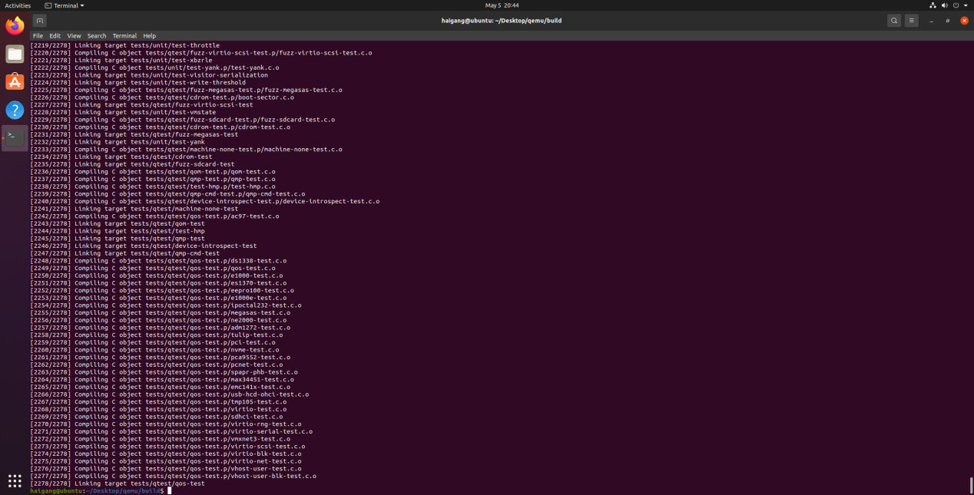

make install

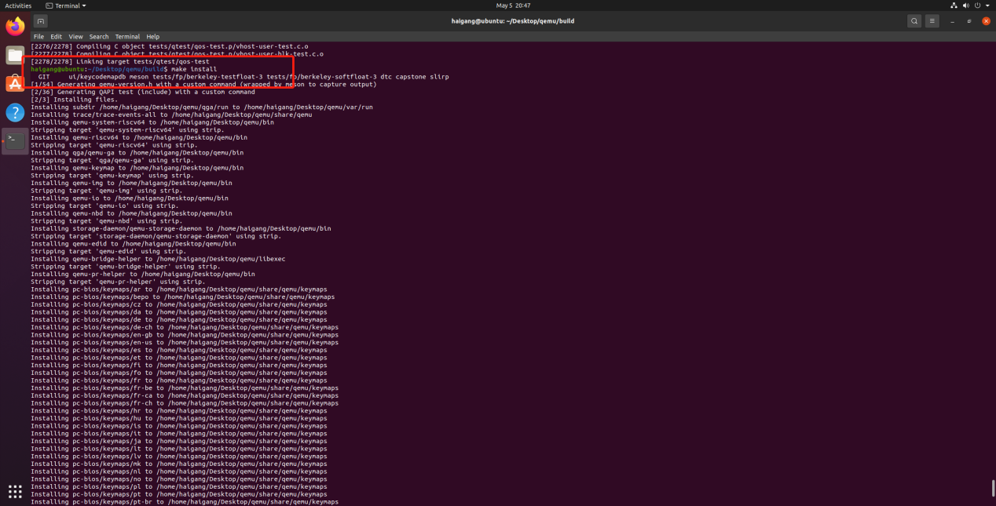

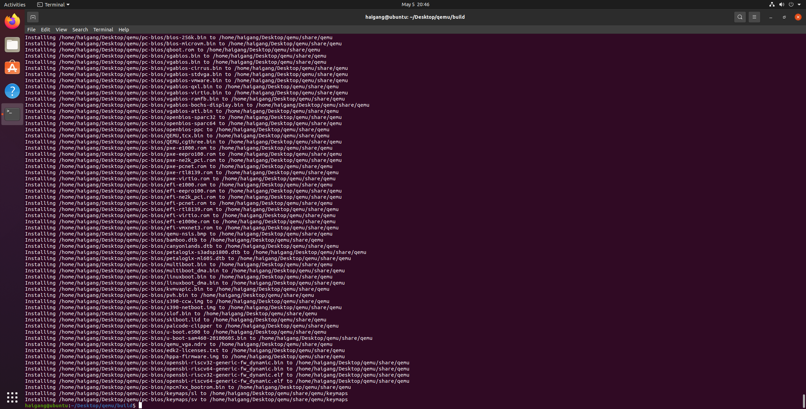

Ubuntu上配置环境变量

在环境变量PATH中添加riscv64-qemu所在目录，使相关命令可以直接使用

vim ~/.bashrc

~/.bashrc文末添加

export QEMU_HOME=/home/haigang/Desktop/qemu

export PATH=$QEMU_HOME/bin:$PATH

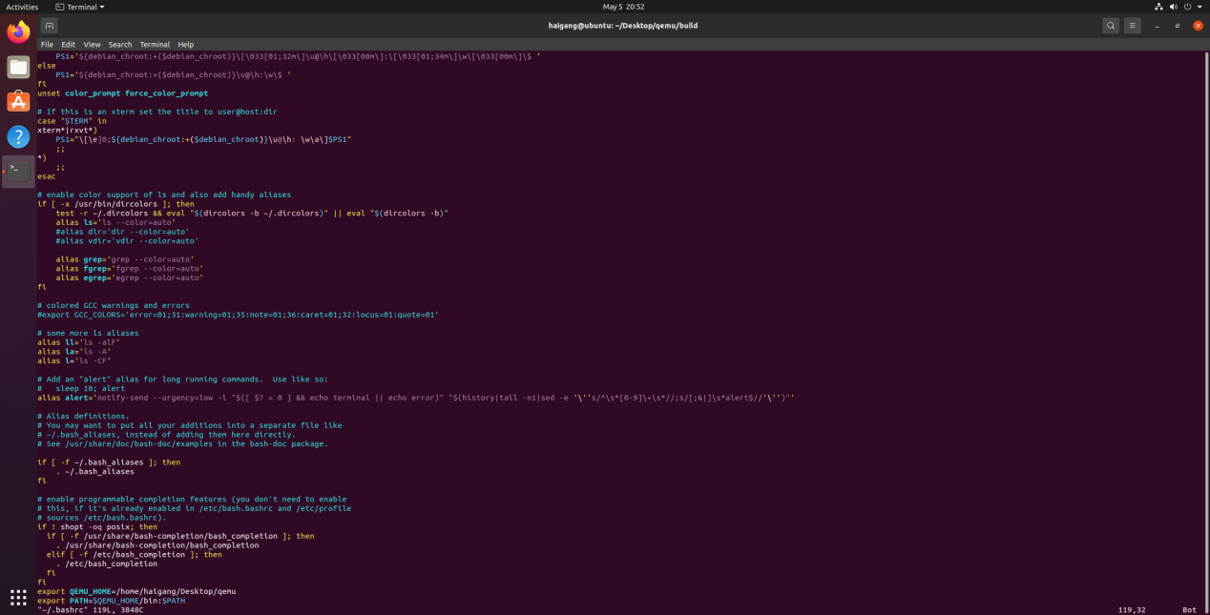

检查是否添加成功

source ~/.bashrc

echo $PATH

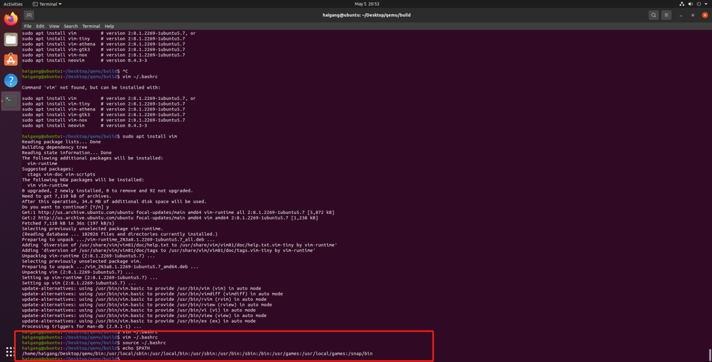

验证安装是否正确

qemu-system-riscv64 --version

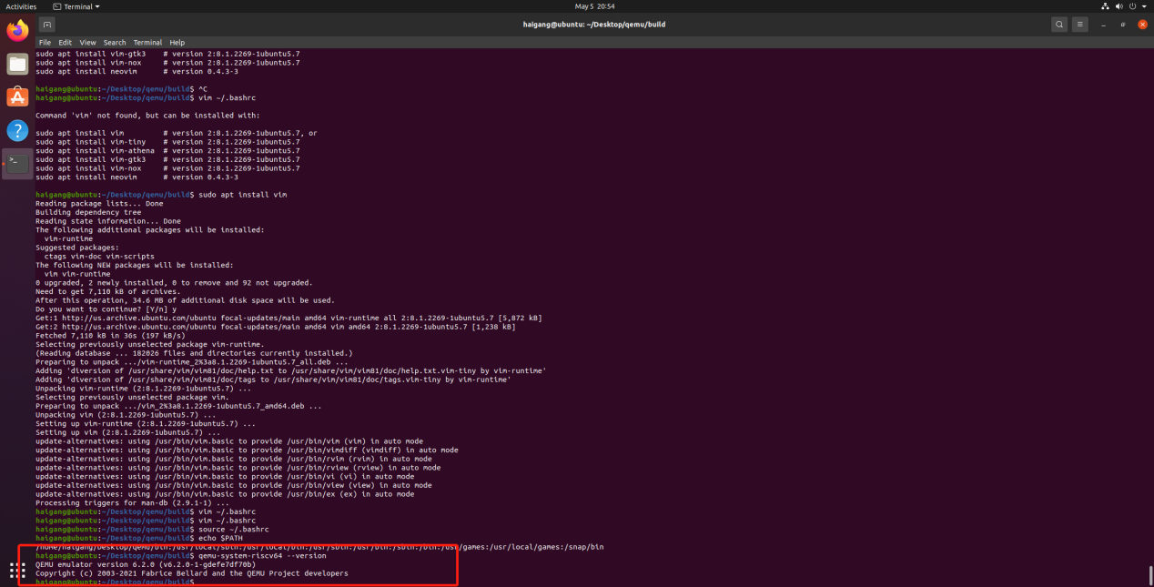

下载 编译支持视频输出的 kernel

git clone https://gitee.com/yunxiangluo/riscv-openeuler.git

cp ./riscv-openeuler/chapter3/class1/Image

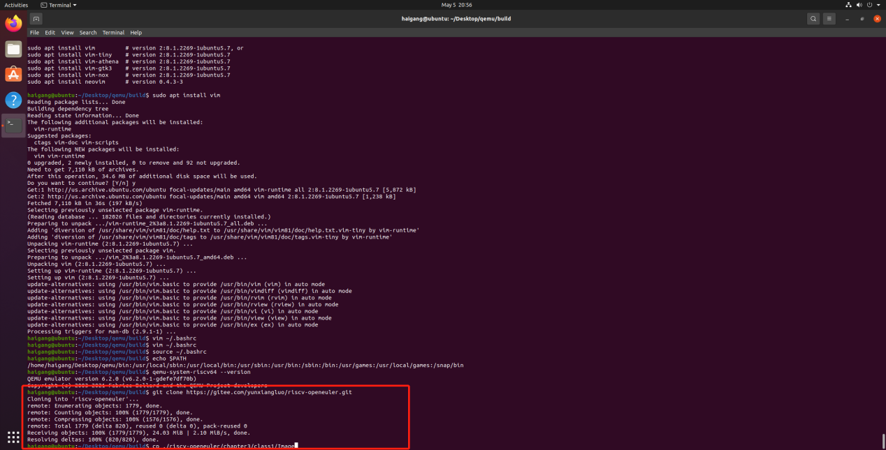

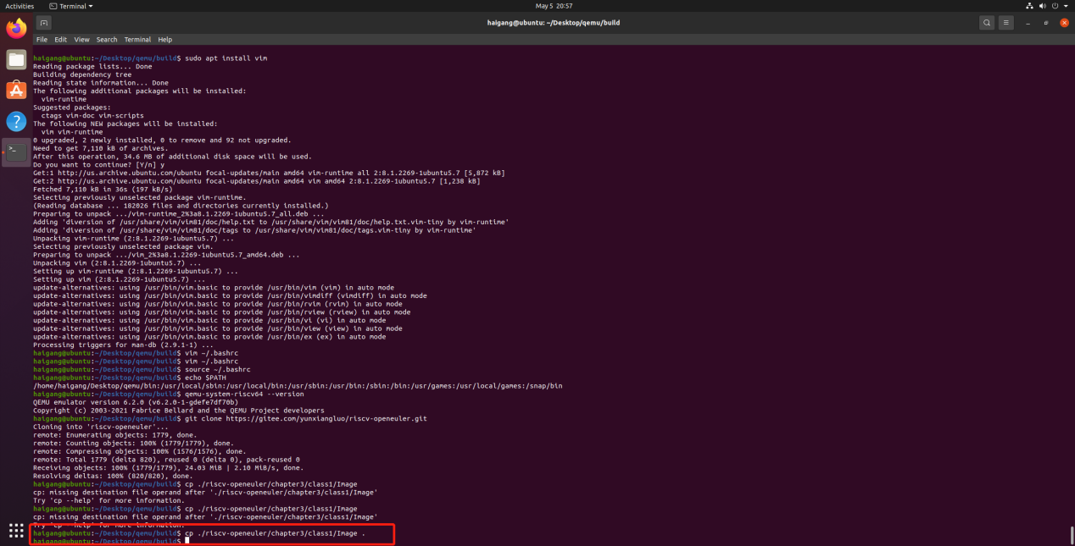

下载 openeuler risc-v 文件系统

wget --no-check-certificate https://mirror.iscas.ac.cn/openeuler/openEuler-preview/RISC-V/Image/openEuler-preview.riscv64.qcow2

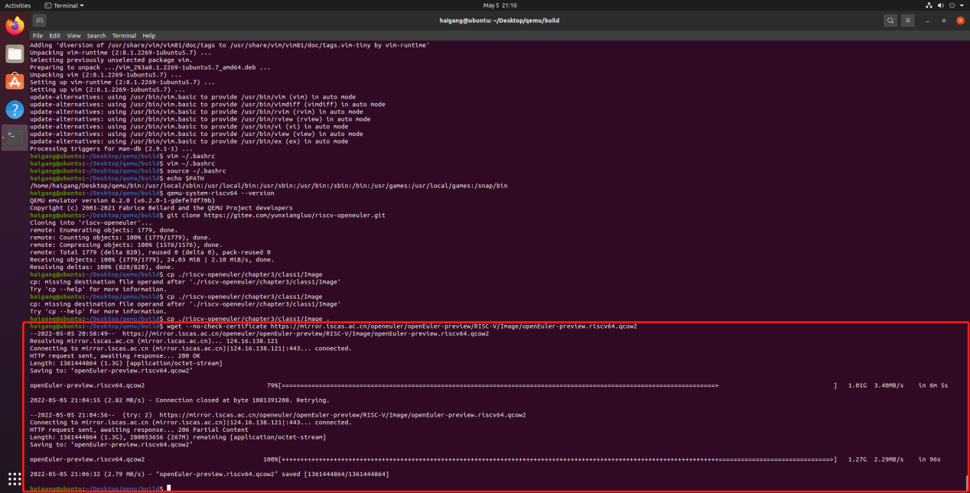

QEMU启动RISC-V openEuler

qemu-system-riscv64 \

-nographic -machine virt \

-smp 8 -m 4G \

-display sdl -vga std \

-kernel Image \

-append "loglevel=3 swiotlb=1 console=ttyS0 rw root=/dev/vda1" \

-drive file=openEuler-preview.riscv64.qcow2,format=qcow2,id=hd0 \

-object rng-random,filename=/dev/urandom,id=rng0 \

-device virtio-rng-device,rng=rng0 \

-device virtio-blk-device,drive=hd0 \

-device virtio-net-device,netdev=usernet \

-netdev user,id=usernet,hostfwd=tcp::12055-:22 \

-device qemu-xhci -device usb-tablet -device usb-kbd

wget https://gitee.com/yunxiangluo/riscv-openeuler/raw/master/chapter3/class1/start_oe.bash

chmod +x ./start_oe.bash

./start_oe.bash

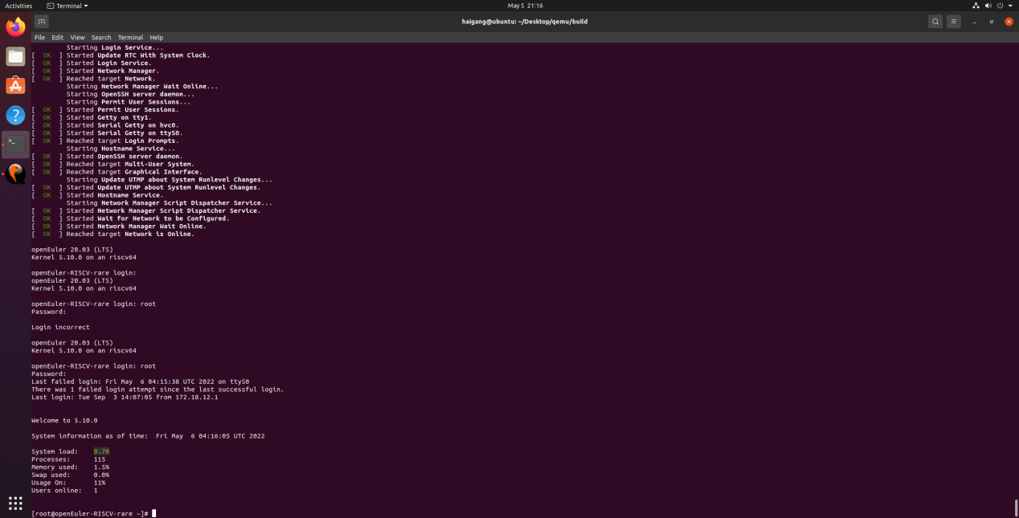

首先配置时间

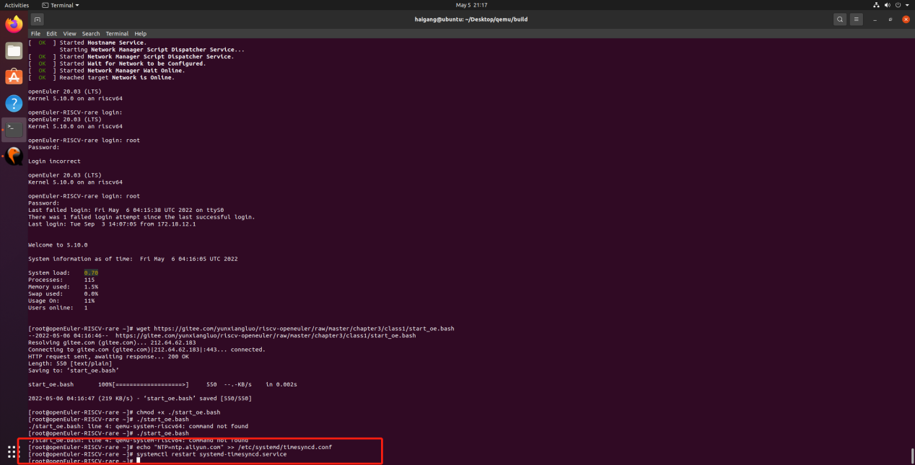

配置DNS

vim /etc/resolv.conf

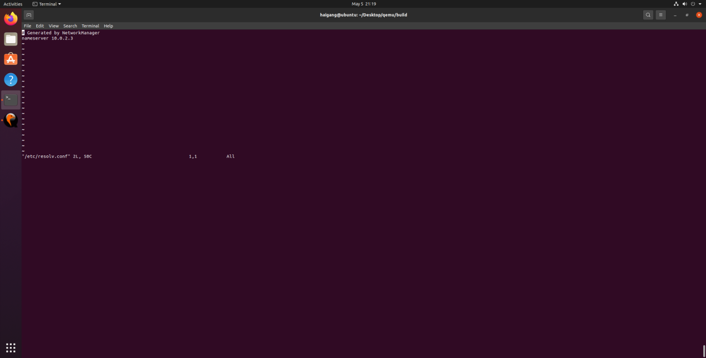

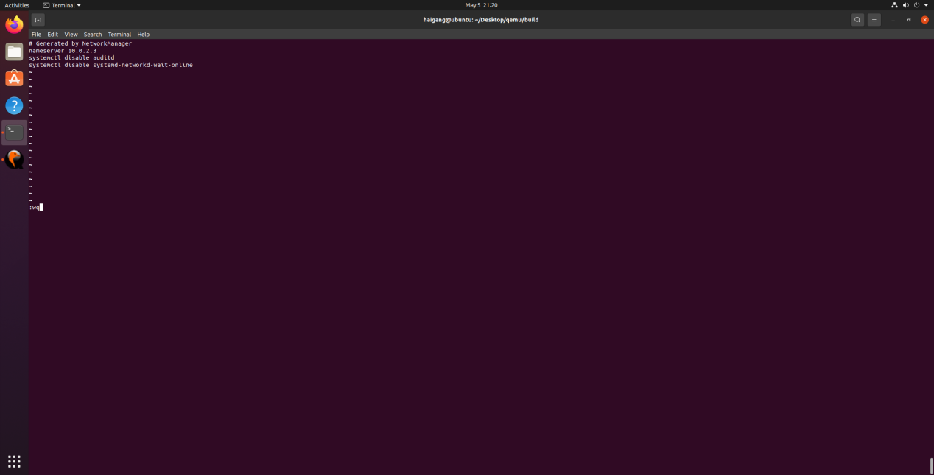

添加xfce软件源

vim /etc/yum.repos.d/oe-rv.repo

文件末尾添加：

[standard]

name=standard

baseurl=https://mirror.iscas.ac.cn/openeuler-sig-riscv/openEuler-RISC-V/development/2203/Everything/

enabled=1

gpgcheck=0

[xfce4]

name=xfce4

baseurl=http://121.36.3.168:82/home:/pandora:/xfce4/webkit2gtk3/

enabled=1

gpgcheck=0

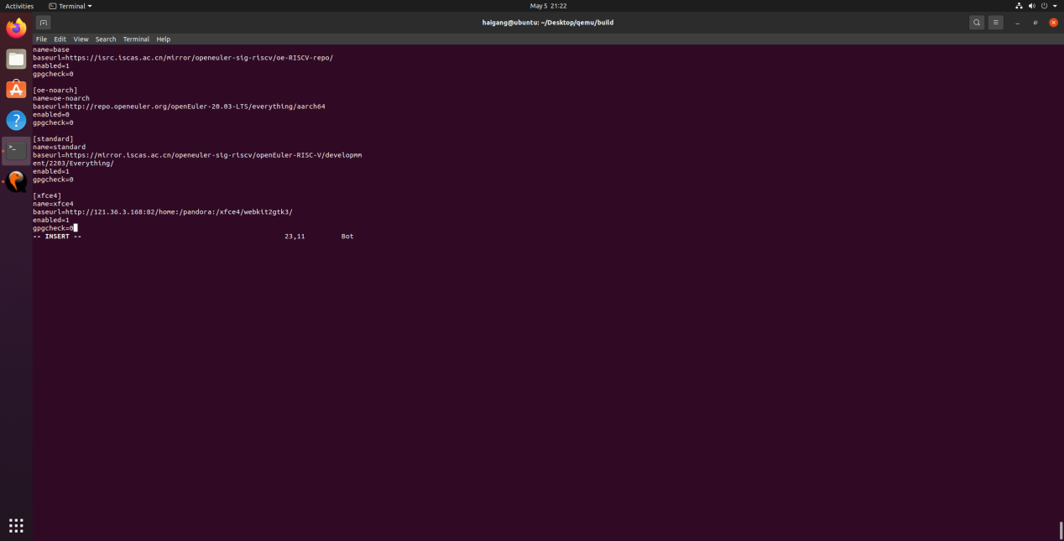

安装 xfce4

yum install libxfce4util xfconf libxfce4ui exo garcon thunar thunar-volman tumbler xfce4-appfinder xfce4-panel xfce4-power-manager xfce4-settings xfdesktop xfwm4 xfce4-session xfce4-terminal -y



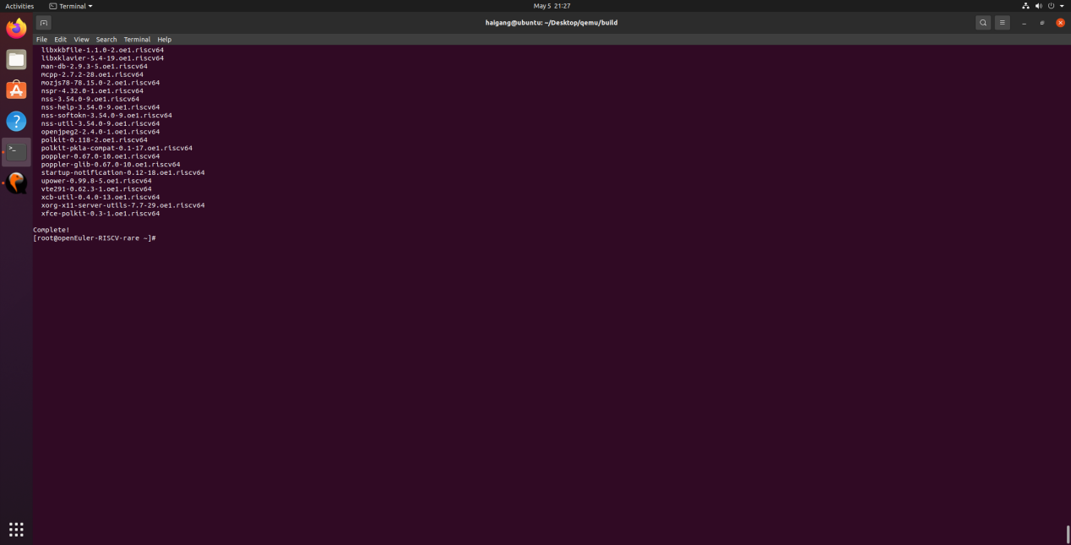

再安装 xorg 的软件包 xorg-x11-xinit 和 xorg-x11-server，更新文件管理器pango到新版本。

yum install xorg-x11-xinit xorg-x11-server -y

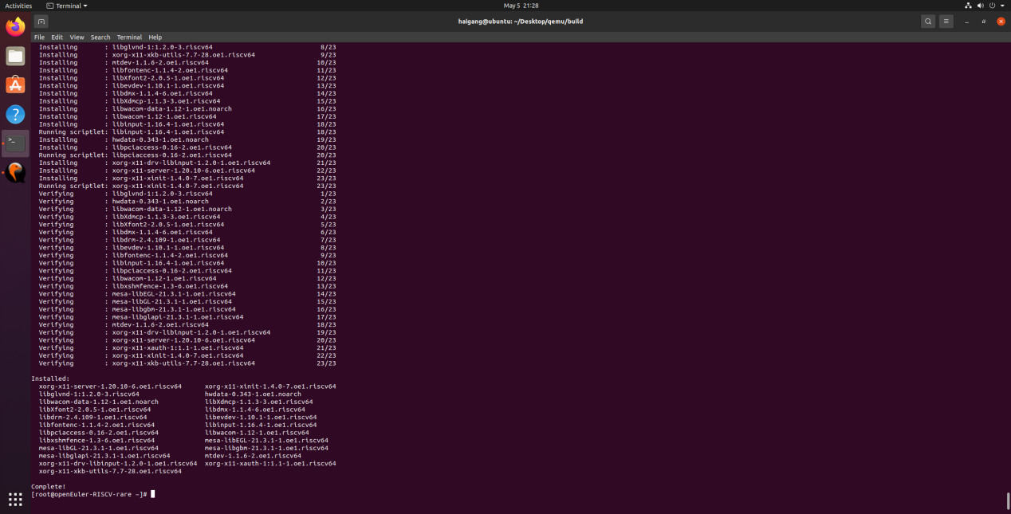

在视频输出窗口中输入 startxfce4 启动 xfce4。

startxfce4

